**EXPERIMENT 5**

**BINARY HALF ADDER & BINARY FULL ADDER**

**OBJECTIVE:**

To design and set up a half adder using

(a) XOR gates and NAND gates

(b) NAND gates only

To design and set up a full adder using   
  
(a) XOR gates and NAND gates

(b) NAND gates only

**Required IC’s:**

7408 AND Gate

7432 OR Gate

7486 XOR Gate

**Theory:**

**Binary Addition**

Digital arithmetic is one of the most fundamental operations to be performed by digital logic circuits. Three basic digital circuits are used to perform arithmetic functions: The exclusive-OR gate, the Half-Adder (H.A) and the Full-Adder (F.A).

**Half-Adder**

A half adder is a logical circuit that performs an addition operation on two binary digits. The half adder produces a sum and a carry value which are both binary digits. The Boolean logic for a half adder is as follows.

S = A XOR B

C = A AND B

The block diagram of a half adder is shown below & completes the truth table for the half adder.

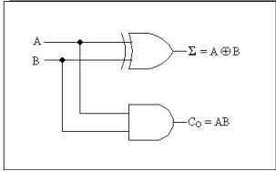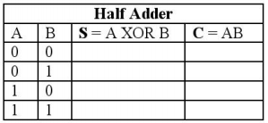

Construct the circuit on a breadboard with switches and 2 LEDs. Experimentally verify the truth table. A and B are switches. The output for each logic gate will be on an LED.

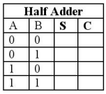

**Full-Adder**

A full adder is a logical circuit that performs an addition operation on three binary digits. The full adder produces a sum and a carry value, which are both binary digits. The Boolean logic for a full adder is as follows.

S = (A xor B) xor Ci

Co = (A and B) or (Ci and (A xor B)) = (A and B) or (B and Ci) or (Ci and A)

The block diagram of a full adder is shown below & completes the truth table for the full adder.

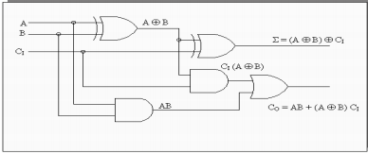

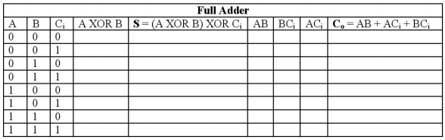

Construct the circuit on a breadboard with switches and 2 LEDs. Experimentally verify the truth table.

A and B are switches. The output for each logic gate will be on an LED.

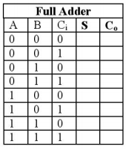

**CONCLUSION**